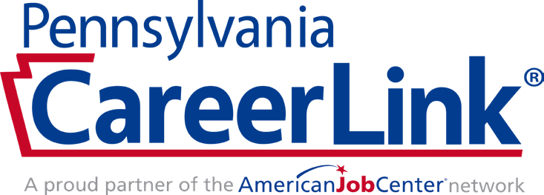

Equal opportunity employer/program. Auxiliary aids and services are available upon request to individuals with disabilities. Services provided by the Central PA CareerLink

®

network

including Business Services, Career Services and Training Services are 100% funded through the US Department of Labor under the Workforce Innovation & Opportunity Act.

**LEARN MORE TODAY!**

dreber@censop.com

(570) 274-5097

*)*

*(*

*call or text*

CentralPACareerLink.org



**CAMP**

**STEAM**

**April 17th-19th**

**April 24th-26th**

Earn $150

**INTERACTIVE**

**ENGAGING**

**HANDS-ON**

**JOIN NOW**

•

Learn more about jobs at

local businesses

•

Explore training options

•

Develop your career pathway plan

•

Learn skills that businesses are

looking for when they hire

•

Participate in fun activities with your friends

Available to students

in 9th-12th grade

